**Exploring Global Tuberculosis Reports Data**

The "Exploring Global Tuberculosis Reports Data" project is a comprehensive data analysis endeavor aimed at unraveling the details behind the Reports. It involves collecting, processing, and analyzing reports of Tuberculosis from various countries that the World Health Organization has collected to derive actionable insights. This project aims to provide valuable information to the medical industry and the Pharmaceutical Industry.

**Technical Architecture:**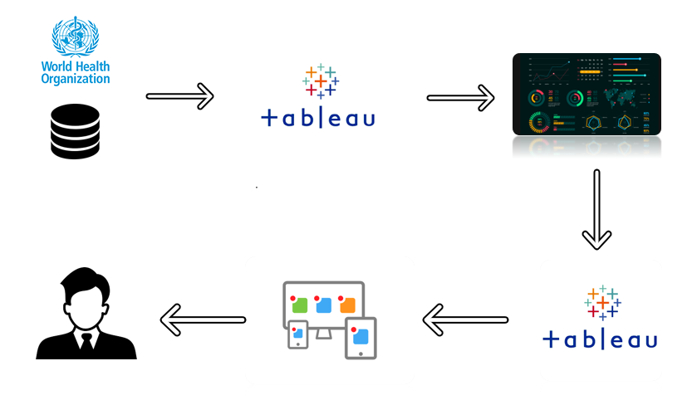

**Project Flow**

To accomplish this, we have to complete all the activities listed below,

Define Problem / Problem Understanding

* + Specify the business problem
  + Literature Survey
  + Social or Business Impact.
* Data Collection & Extraction from Database
  + Collect the dataset,
  + Connect dataset with Tableau
* Data Preparation
  + Prepare the Data for Visualization
* Data Visualizations
  + No of Unique Visualizations
* Dashboard
  + Responsive and Design of Dashboard
* Story
  + No of Scenes of Story
* Web Integration
  + Dashboard and Story embed with UI With Flask
* Project Demonstration & Documentation
  + Record explanation Video for project end to end solution
  + Project Documentation-Step by step project development procedure

**Milestone 1: Define Problem / Problem Understanding**

The problem at hand is to explore and analyse Global Tuberculosis data comprehensively. This analysis aims to provide valuable insights into various aspects of the medical industry and the Pharmaceutical Industry using data analytics. The primary goal is to facilitate informed decision-making for Doctors and Researchers.

**Activity 1: Specify the business problem.**

Sales Understanding: The primary challenge is to gain a deep understanding of the reporting dynamics within the specific industry. This includes identifying which areas show ranges of reporting numbers.

**Activity 2: Business requirements**

Data Collection: To identify the variance in reports, the project requires collecting extensive data from various different countries from different regions. This data should include monthly reporting and quarterly reporting’s, geographical locations, and relevant contextual information.

Data Analysis Tools: Effective data analytics tools and techniques are needed to process, clean, and analyse the collected data. This includes statistical analysis, data visualization tools, and machine learning models if applicable.

**Activity 3: Literature Survey**

A literature survey involves a review of existing research, studies, and publications related to tuberculosis and its global extent. This step helps in understanding the context, previous analyses, and gaps in the current understanding of the subject matter. It provides a foundation for conducting a more informed and focused analysis.

**Activity 4: Social or Business Impact.**

Academic Research: Serve as a valuable resource for researchers studying civilian behaviour and data analytics.

Public Awareness: Increase public awareness and understanding of the coffee industry, its trends, and its impact on society.

**Milestone 2: Data Collection & Extraction from Database**

Data collection is the process of gathering and measuring information on variables of interest, in an established systematic fashion that enables one to answer stated research questions, test hypotheses, and evaluate outcomes and generate insights from the data.

Please use the following links to download the dataset:

[**https://www.who.int/teams/global-tuberculosis-programme/data**](https://www.who.int/teams/global-tuberculosis-programme/data)

[**https://extranet.who.int/tme/generateCSV.asp?ds=provisional_notifications**](https://extranet.who.int/tme/generateCSV.asp?ds=provisional_notifications)

**Milestone 3: Data Preparation**

**Activity 1: Prepare the Data for Visualization**

Preparing the data for visualization involves cleaning the data to remove irrelevant or missing data, transforming the data into a format that can be easily visualized, exploring the data to identify patterns and trends, filtering the data to focus on specific subsets of data, preparing the data for visualization software, and ensuring the data is accurate and complete. This process helps to make the data easily understandable and ready for creating visualizations to gain insights into the performance and efficiency.

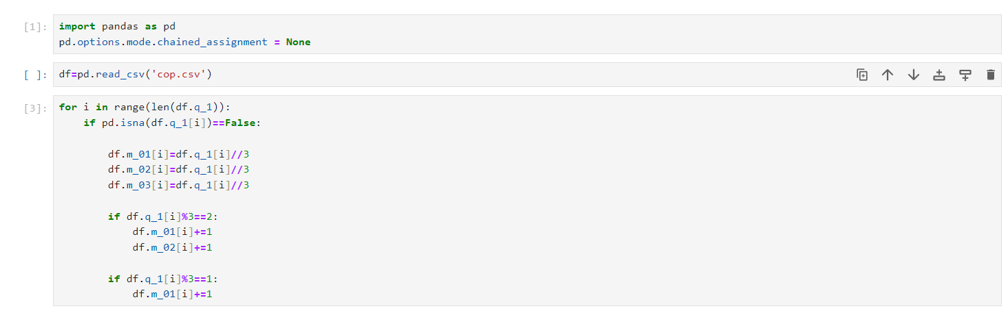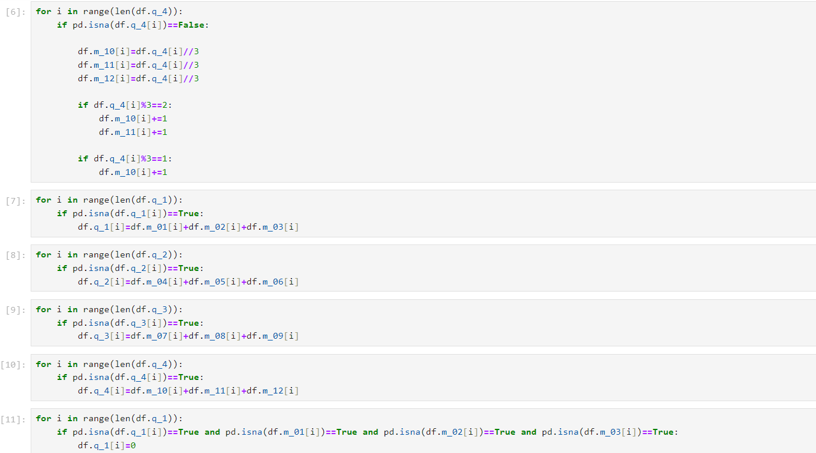

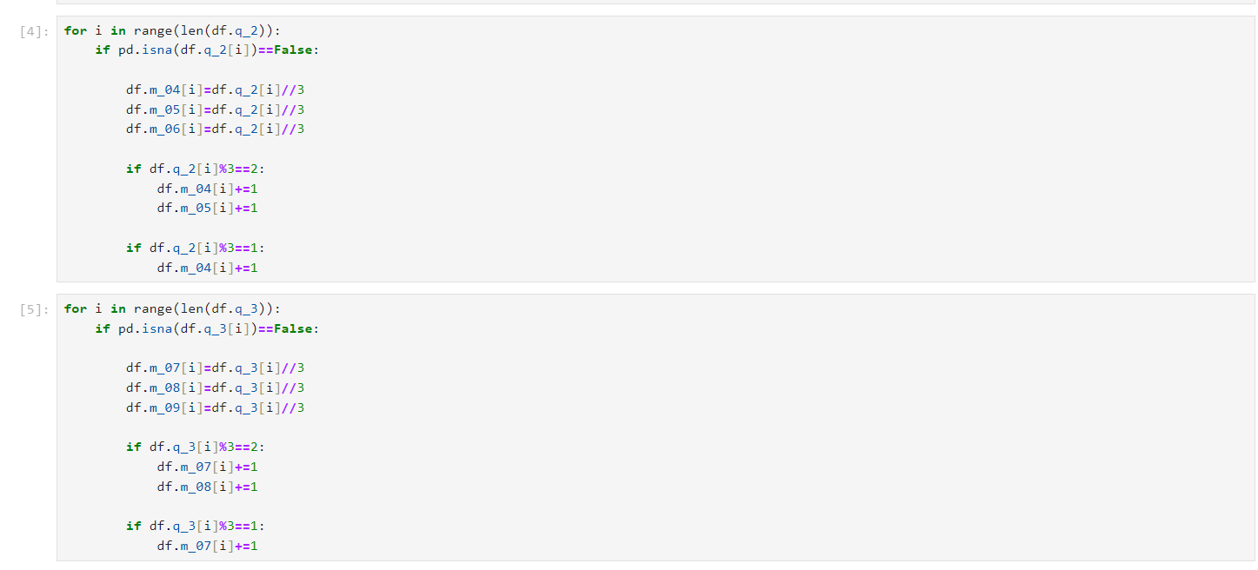

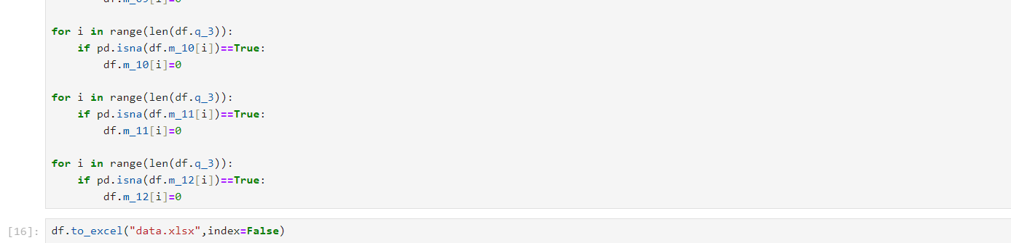

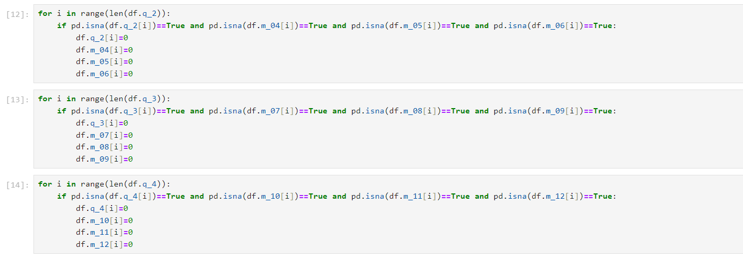

**Milestone 4: Data Visualization**

Data visualization is the process of creating graphical representations of data in order to help people understand and explore the information. The goal of data visualization is to make complex data sets more accessible, intuitive, and easier to interpret. By using visual elements such as charts, graphs, and maps, data visualizations can help people quickly identify patterns, trends, and outliers in the data.

**Activity 1: No of Unique Visualizations**

The number of unique visualizations that can be created with a given dataset. some common types of visualizations that can be used to analyse the data, include bar charts, line charts, columns chart, scatter plots, pie charts, bubbles chart etc. These visualizations can be used to compare performance, track changes over time, show distribution, and relationships between variables.

**Milestone 5: Dashboard**

A dashboard is a graphical user interface (GUI) that displays information and data in an organized, easy-to-read format. Dashboards are often used to provide real-time monitoring and analysis of data, and are typically designed for a specific purpose or use case. Dashboards can be used in a variety of settings, such as business, finance, manufacturing, healthcare, and many other industries. They can be used to track key performance indicators (KPIs), monitor performance metrics, and display data in the form of charts, graphs, and tables.

**Activity :1- Responsive and Design of Dashboard**

The responsiveness and design of a dashboard for analysing the factors important for analysis of coffee chain sales is crucial to ensure that the information is easily understandable and actionable. Key considerations for designing a responsive and effective dashboard include user-centred design, clear and concise information, interactivity, data-driven approach, accessibility, customization, and security. The goal is to create a dashboard that is user-friendly, interactive, and data-driven, providing actionable insights.

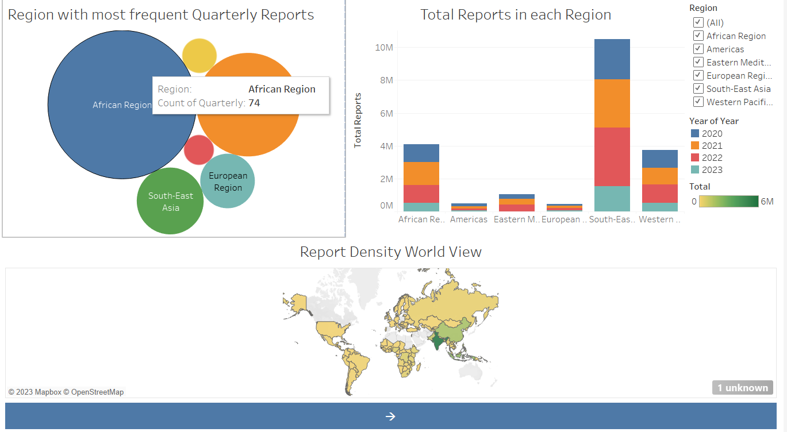

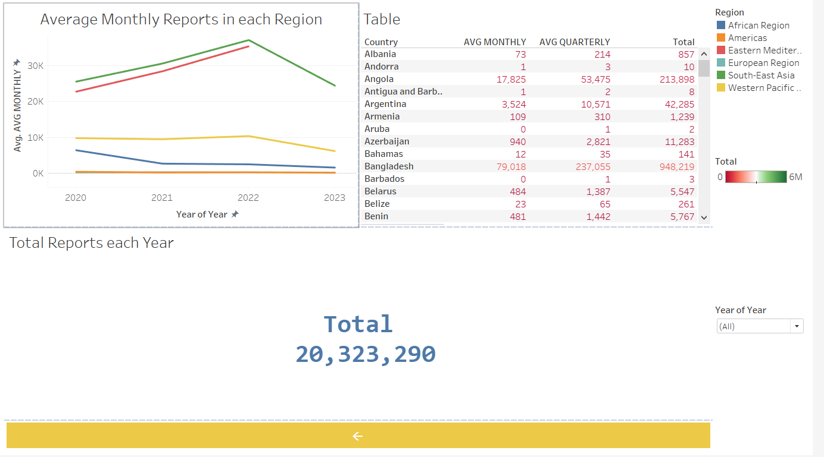

**Milestone 6: Story**

A data story is a way of presenting data and analysis in a narrative format, with the goal of making the information more engaging and easier to understand. A data story typically includes a clear introduction that sets the stage and explains the context for the data, a body that presents the data and analysis in a logical and systematic way, and a conclusion that summarizes the key findings and highlights their implications. Data stories can be told using a variety of mediums, such as reports, presentations, interactive visualizations, and videos.

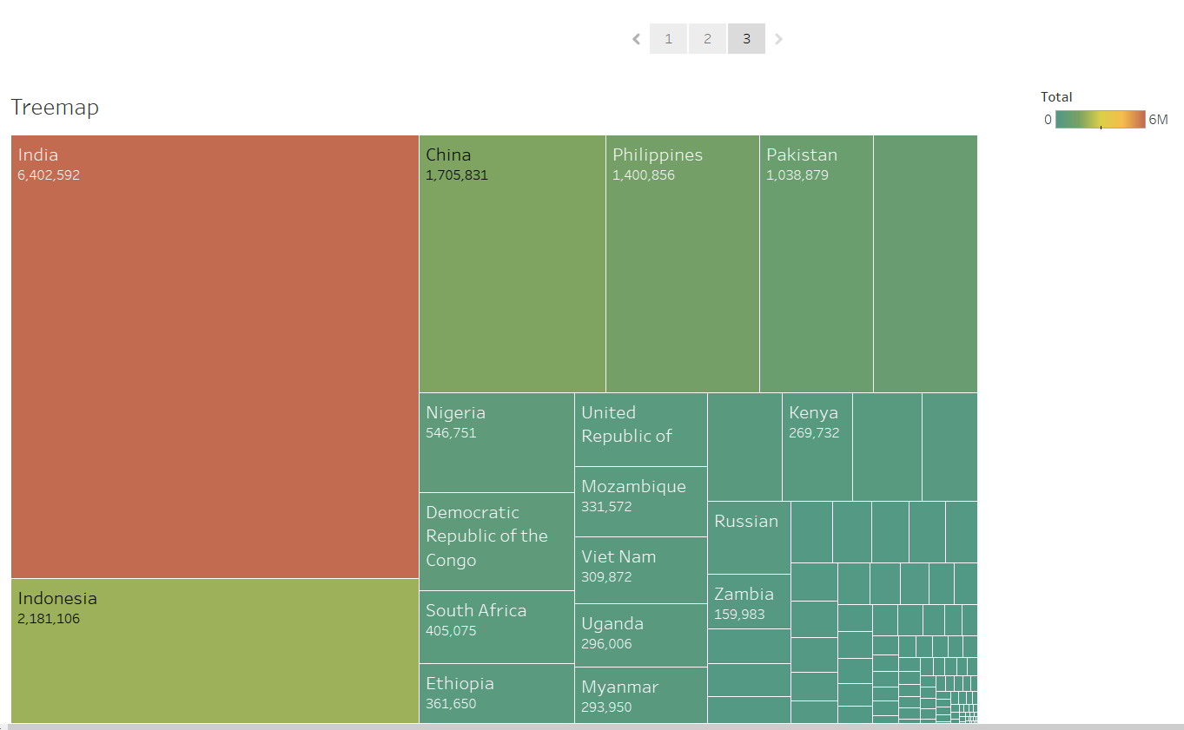

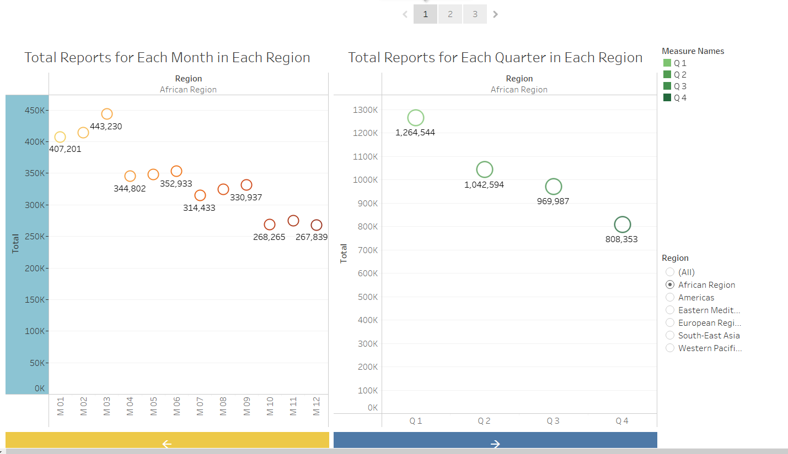

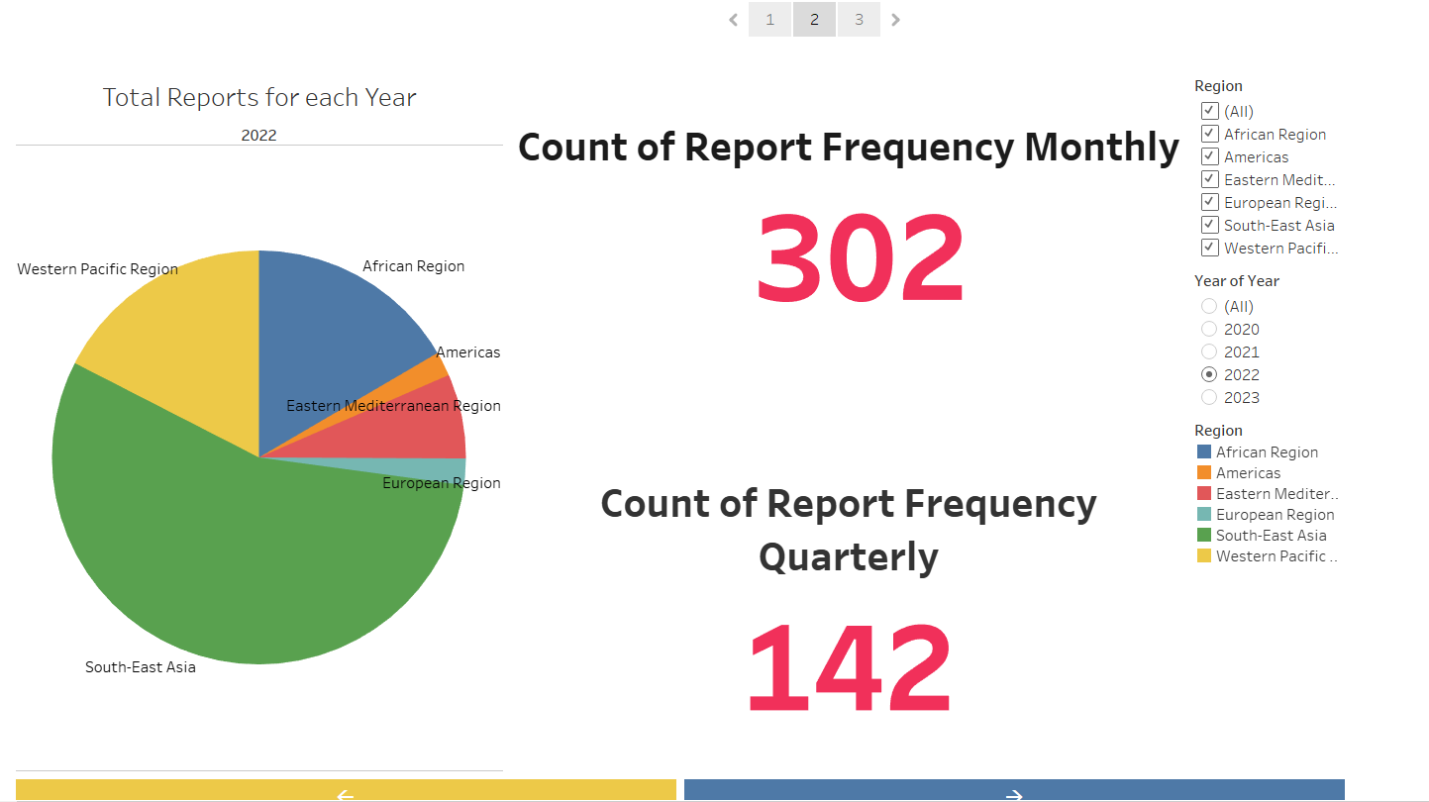 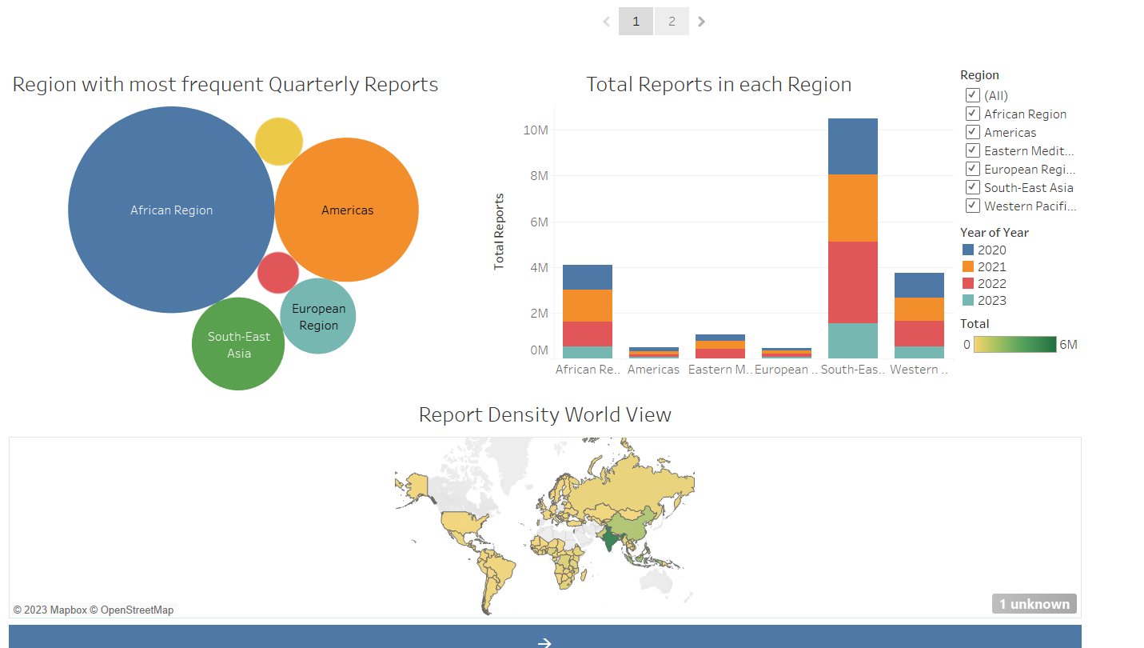

**Milestone 9: Web integration**

Publishing helps us to track and monitor key performance metrics, to communicate results and progress. help a publisher stay informed, make better decisions, and communicate their performance to others.

**Activity 1: Dashboard and Story Transfer to Tableau Public:**

1. You have to Publish your sheet in your tableau public account.
2. Once you publish it, get the link as shown in the video below and paste it in your html code.
3. Then the sheets are displayed.

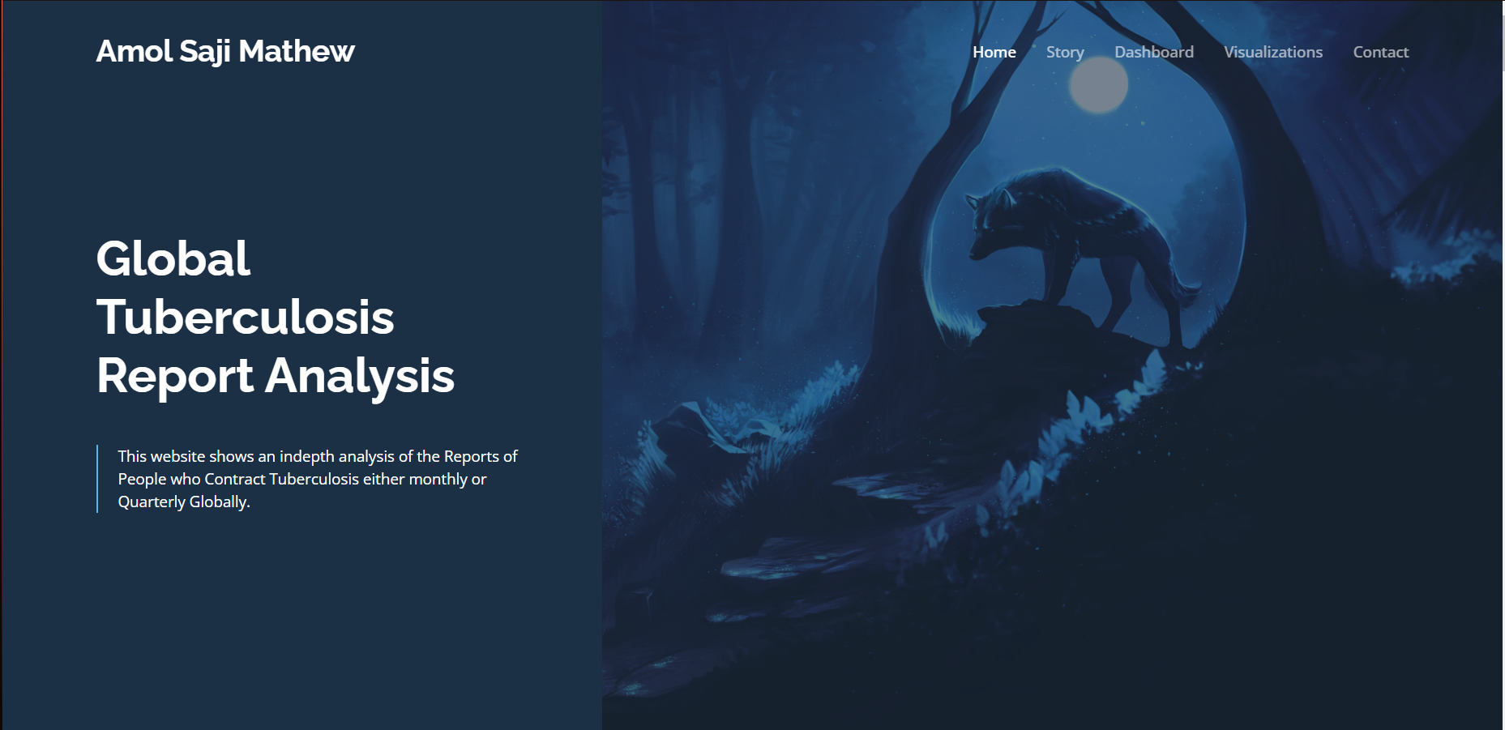

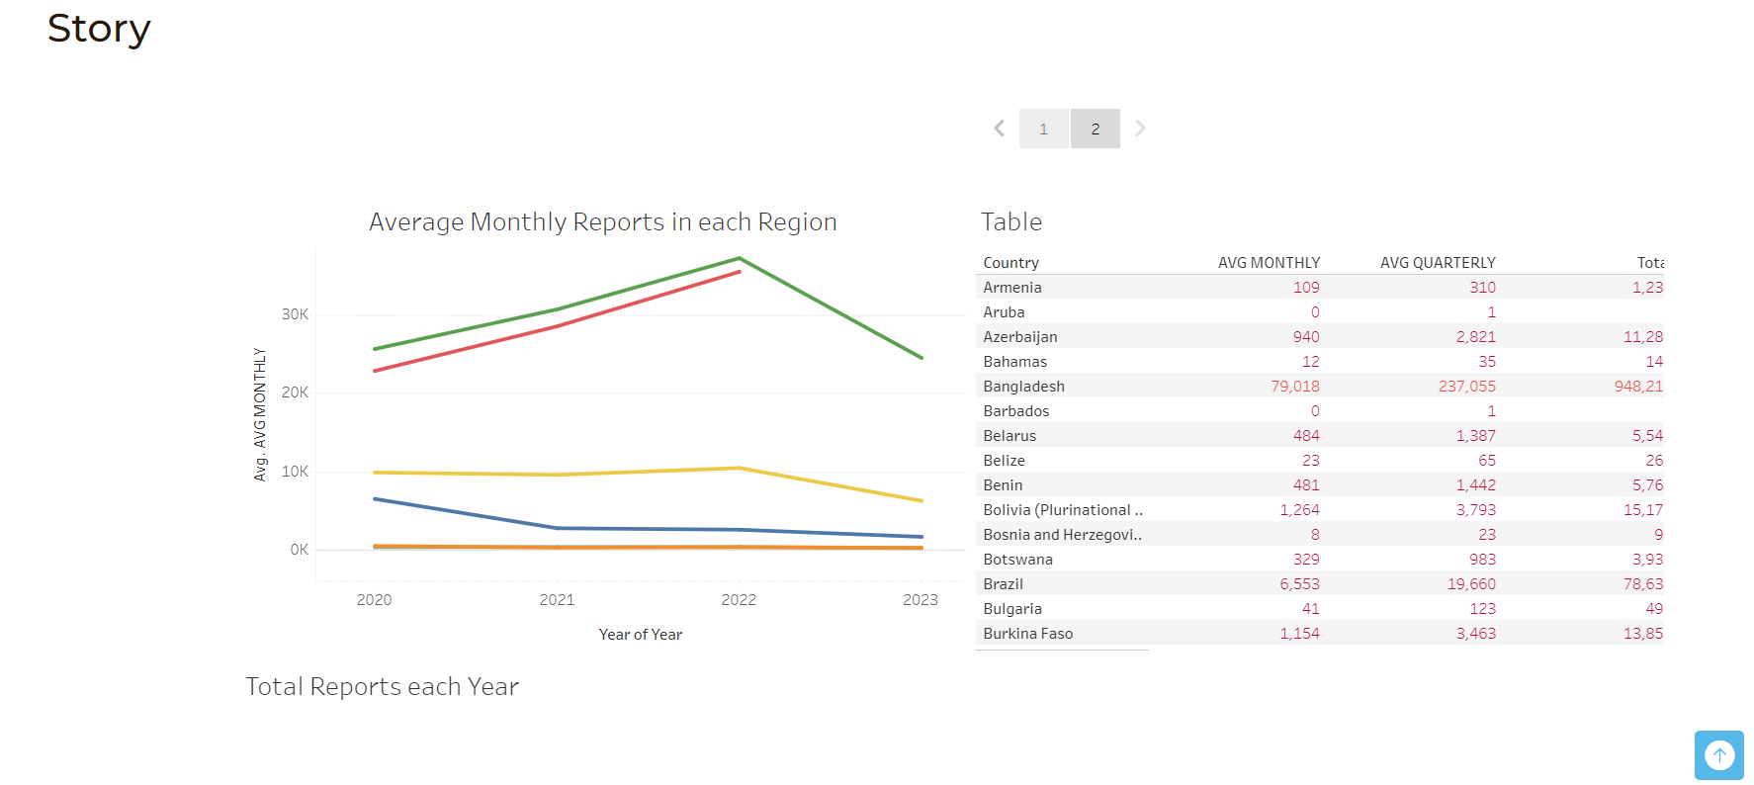

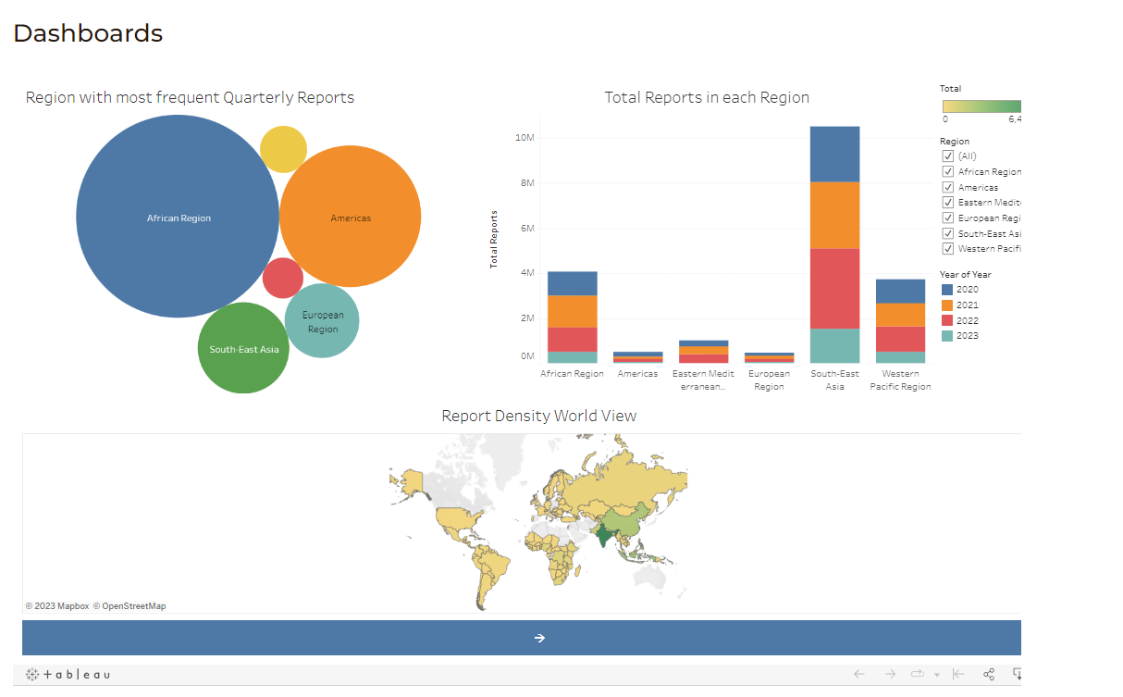

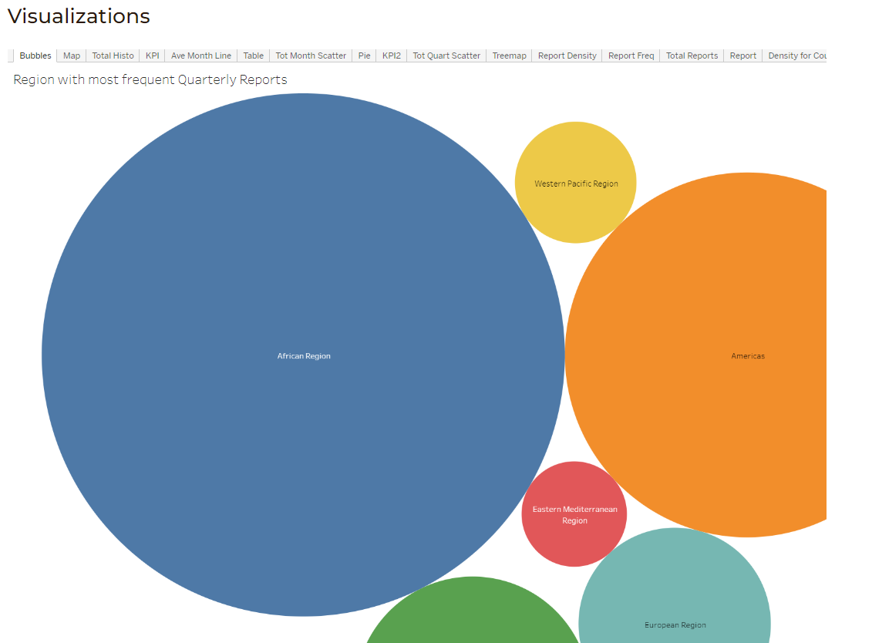

**Milestone 10: Project Demonstration**

Video here